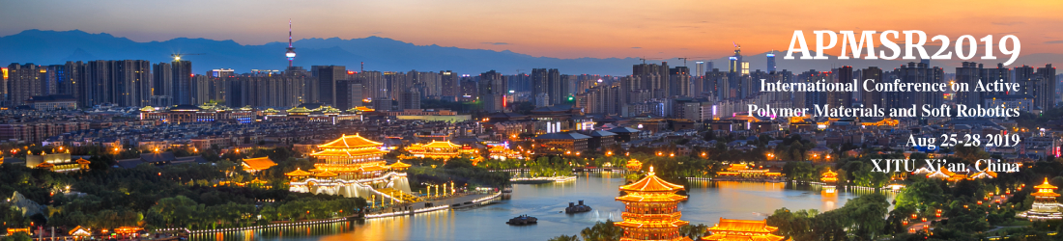
www.apmsr2019.com
Exhibition
- Exhibition Details
  - Period : August 26, 2019
  - ​Place : Fu Rong Ge Hotel, Xi'an, China
  - Participants : Institutes, societies, and companies related to Active Polymer Materials and Soft Robotics
- Exhibition Booth Size: Table
- Provided Benefits
  - A table, 1 socket(220v), 2 chairs, power(1kW)
  - In case you need an extra power and LAN at your booth, please let us know in advance.
- How to Apply
  - Please send the completed form below by E-mail (apmsr2019@outlook.com)

Exhibition Application
Organization
Name of President
Address
Unit of Booth
Key Exhibition Item
Contact Person/Position |  | Phone
E-mail |  | Mobile
Additional Requirement:

We confirm our participation as a sponsor at the APMSR2019 and reaffirm that we have read and agreed to the general terms and conditions.

Date :
Name of Applicant : (Signature)

